Auditdata SWAP service
Instructions for the proper transducer exchange in place

Introduction
This document explains how to ensure that the new transducer was recognized by Measure fitting unit.

Instructions
- Connect the Fitting Unit to the PC using the USB cable.
- Start Measure.
- Wait until the Fitting Unit is initialized and connected. The current connection status is displayed on the right side of the status bar at the bottom of the screen.
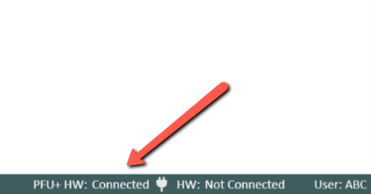
- Disconnect the old transducer.
- Connect the new transducer to the Fitting Unit.
- In Measure, go to Help > License Information > Connected Devices.
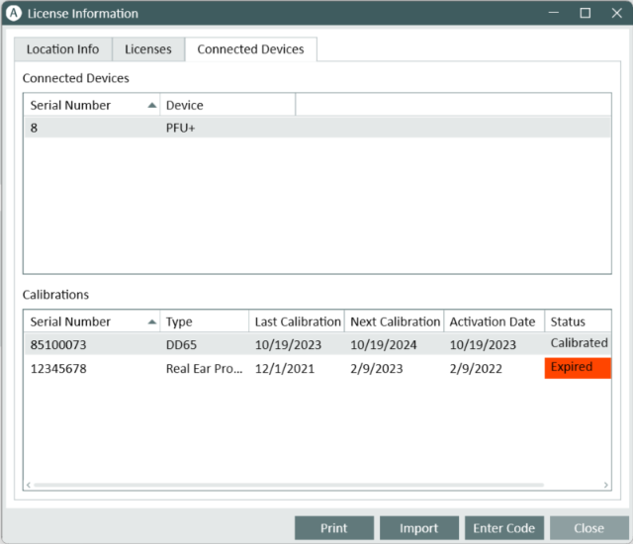
- Review the name and serial number of the new transducer.
If the data corresponds to the new transducer, you can start using the system normally.
If the data corresponds to the old transducer, proceed with the next steps.
- In Measure, go to Tools > Refresh Transducer Data.
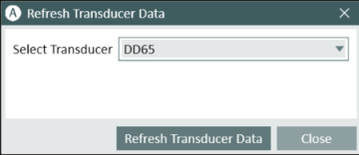
- Select the needed transducer and click Refresh Transducer Data.
- Wait until this process is finished and close this window.
- You can close the window and start using the system normally.

